**GROUP 1 ASSIGMENT**

**IS 611 – ADVANCED OBJECT ORIENTED PROGRAMMING WITH JAVA**

Daniel Mushi 2019-06-02005

Edward Mwangile 2019-06-11012

Frank Tilugulilwa 2019-06-02504

**COURSE WORK TOOL** Manual

**Introduction**

This tool is just a prototype for demonstration of course concepts covered so far which includes but not limited to

1. Graphical User interfaces ( e.g. JFrame, JPanel etc)
2. Networking
3. Database Access (MySQL, JDBC Drivers, IDE, SQL queries)
4. Distributed Programming – Sockets, Java RMI
5. Collaborative Environment

We have developed Client Server Application where the Server and Clients can reside on two different JVMs or even physical machine.

In this case, the Server application is responsible for loading student coursework scores while the client applications is responsible for querying combined CW for a specific student or course.

The setup is built on top of Java RMI architecture.

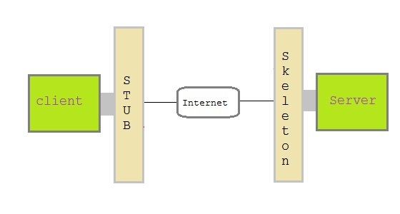

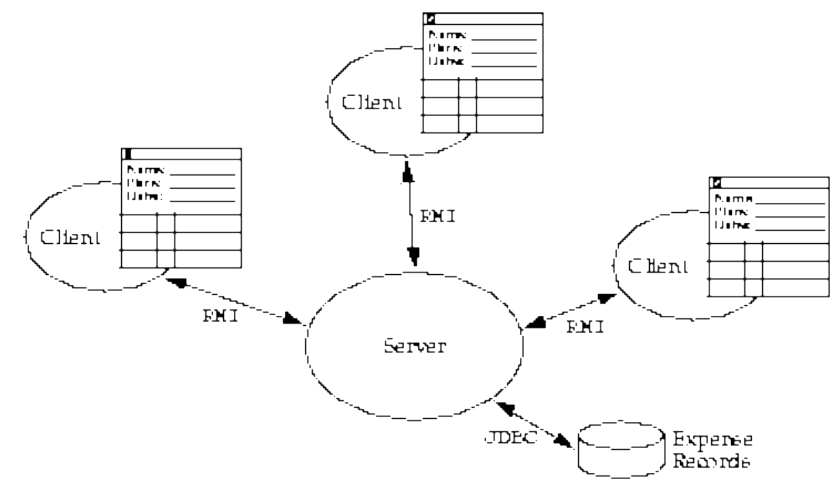

**Tools and Technologies deployed**

We have explored the following tools and technologies

1. Netbeans 8.2 as an IDE with Java/JDK 8
2. MySQL Community Server 5.6.47
3. MySQL JDBC Connector
4. Java RMI
5. 2 Windows machines (networked)

**Deployment**

The Server Application requires MySQL Community Server 5.6.47, Java 8 Runtime Environment, capable of running RMI Registry services. The tool is shipped with two binaries; i.e. one for client (**CourseClientRemote**.jar) and other one for the server (**CourseServer**.jar) with their respective helper classed under **lib** folder.

To start the server just execute jar file **CourseServer**.jar by clicking it and then start the client application by also executing the **CourseClientRemote**.jar

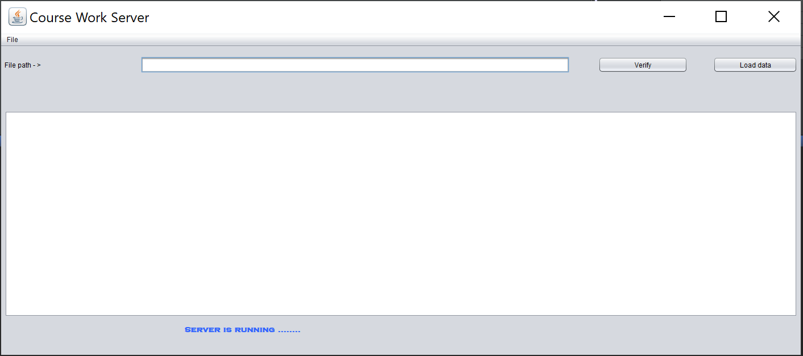

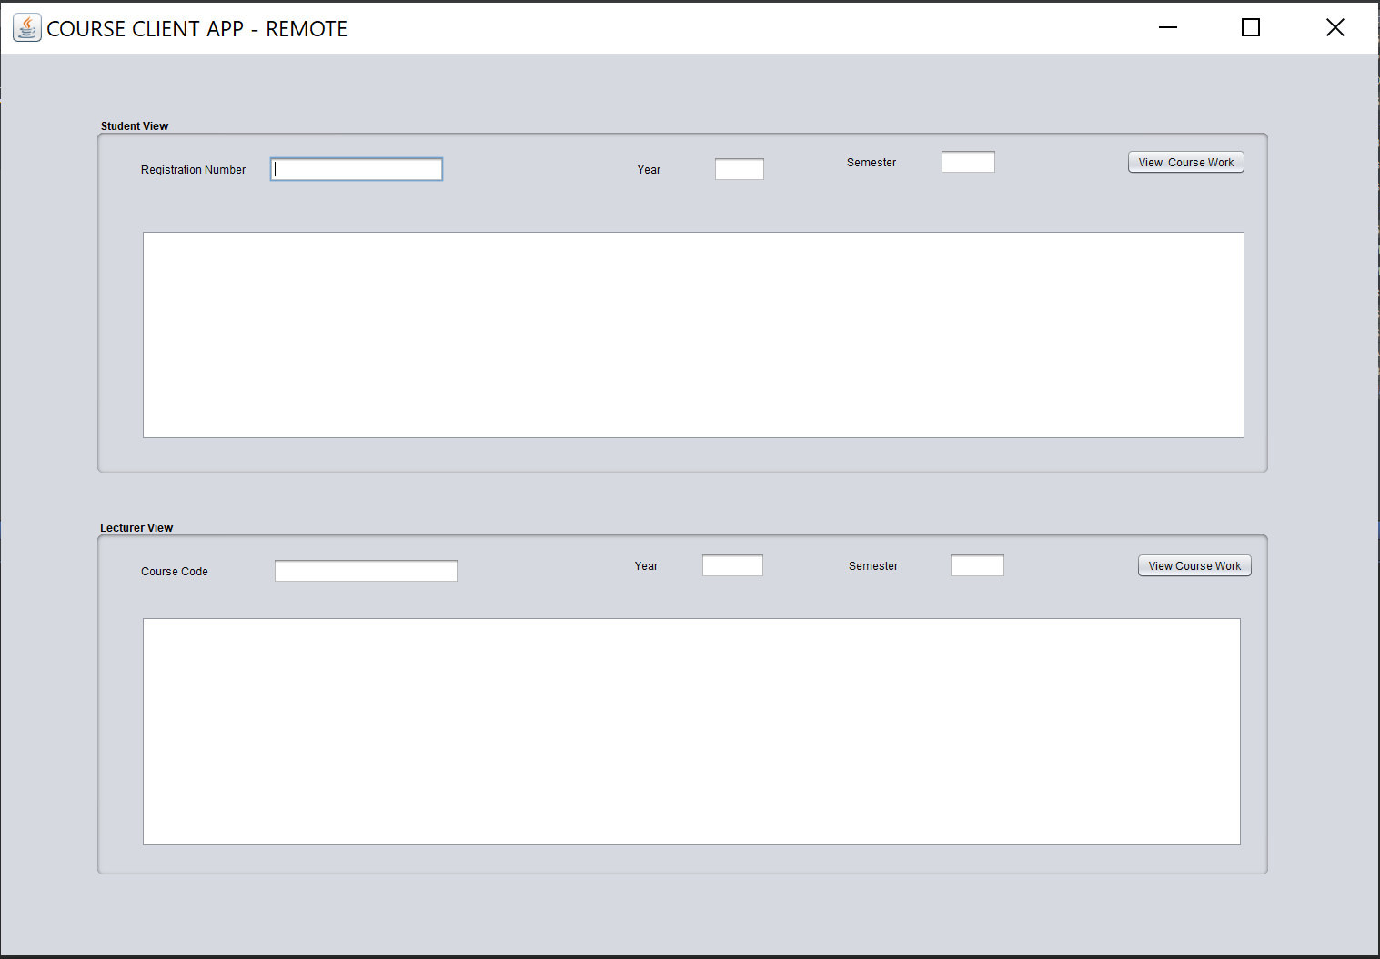

**How to operate**

Course work for each subject must be a text file with comma separated values (CSV) loaded using Server Applications

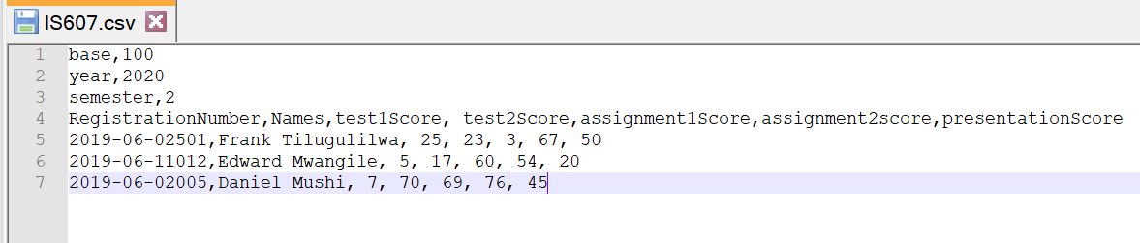

The Client Applications allows two views – one for a specific student and other for a specific course given a year and specific semester.

